**Chapter 7: Synchronization Constructs**

When we are developing an application which will be executed synchronously shared resources can be used with minimal handling as we know that at any point in time only one thread is executing our code and we don’t need any specific handling for in memory variables because they are not shared across multiple threads. However, if our application supports executing a piece of code concurrently/parallelly, handling shared resources should be one of the top priorities, not doing so would result in abnormal results. We will run into situations like dead locks, race conditions or getting contrasting output for same piece of code executed at different times. To solve this, we need to additionally implement something very commonly known as thread synchronization or what is also known as thread safety. In this chapter we will see what thread synchronization is, why we need it, what can go wrong when parallel threads are not synchronized. .Net provides various synchronization constructs like locks, Semaphores, Mutex etc., we will further look on how these can be implemented to achieve thread synchronization

**Structure**

* Overview (Why Synchronization)
* Locking Constructs
  + Exclusive
  + Non- exclusive
* Signaling Constructs
* Other synchronization classes
* Summary

**Objectives**

By end of this chapter reader should be able to understand

* Why we need synchronization
* What are the exclusive locks/non-exclusive locks?
* Thread signaling
* How to use constructs like Mutex, Semaphores, AutoResetEvent, ManualResetEvent Barrier.

**Overview**

When we design a highly scalable application accessed by many concurrent users, there is a high possibility that same data is read/write my multiple users at the same time. If write operation on the shared data across threads is not handled correctly (Synchronously) it will lead to unexpected output. Let’s see this with an example of transactions in a bank account

1. Initial amount in bank account 1000 units.
2. A withdraw request of 500 units is placed through an ATM
3. Sametime another with draw request of 600 units is placed through internet banking

Assuming both transactions are initiated exactly at the same time both would see a balance of 1000 units and will allow both the transactions to pass successfully, however, this will lead to inconsistent state with data. If handled correctly one of the steps should fail with an exception like “Insufficient balance”. This handling of data across threads is done using synchronization and will help getting a predictable outcome. Let’s see this with an example in which we add money to bank account through multiple concurrent transactions. We start creating BankAccount Class and add methods to increase available balance, will start with creating class and 2 private variables accountBalance and numberOfTransactions. Implementation pf BankAccount Class will look like below

public class BankAccount

{

private long accountBalance;

private int numberOfTransactions;

public int NumberOfTransactions

{

get

{

return numberOfTransactions;

}

}

public BankAccount(long initialAccountBalance)

{

this.accountBalance = initialAccountBalance;

numberOfTransactions = 0;

}

public long ShowBalance()

{

return this.accountBalance;

}

}

Now add a private method AddBalanceToAcccount as below to BankAccount class that takes amount as a parameter and increments account Balance and numberOfTransactions

async Task AddBalanceToAcccount(long amount)

{

await Task.Delay(1);

accountBalance = accountBalance + amount;

numberOfTransactions = numberOfTransactions + 1;

}

Create another public async method AddMoneyToAccountAsync which will run a loop and call AddBalanceToAcccount, basically what we are doing here is parallelly simulating 50 transactions. AddMoneyToAccountAsync will look like below

/// <summary>

/// Add money to account through multiple transactions

/// </summary>

public async Task AddMoneyToAccountAsync()

{

var tasks = new Task[50];

for (int i = 1; i <= tasks.Length; i++)

{

tasks[i - 1] = AddBalanceToAcccount(i);

}

await Task.WhenAll(tasks);

}

Calling it through a console application expected value of variable accountBalance for 50 iterations should be 1275

static async Task Main(string[] args)

{

BankAccount bankAccount = new BankAccount(0);

Console.WriteLine($"Initial Balance {bankAccount.ShowBalance()}");

await bankAccount.AddMoneyToAccountAsync();

Console.WriteLine($"Current Balance {bankAccount.ShowBalance()}, total number of transactions - {bankAccount.NumberOfTransactions}");

Console.Read();

}

Once we run this application output will look like below



**Figure 7.1 – Output of application without synchronization**

We can clearly see that it’s lesser than wat is expected and in reality what has happened here is since multiple threads are parallelly accessing same variable at the same time and there is no restriction on overwriting values and at some point few of the threads have overwritten value of variable accountBalance and hence unpredicted outcome. Same has happened with variable numberOfTransactions.

To overcome this we need a mechanism to stop multiple threads parallelly accessing shared resources which is what synchronization is about. Hence to fix above code we can use one of the synchronization construct, in this case locks. With that implemented at any given point in time only one thread can access the resources in another words only one thread can enter critical section and all other threads that need access to critical section shall wait till lock is released by owning thread.

So, we create a locking object and lock critical section using that as and our method will look like this

//Lock

object locker = new object();

async Task AddBalanceToAcccount(long amount)

{

await Task.Delay(1);

lock (locker)

{

accountBalance = accountBalance + amount;

numberOfTransactions = numberOfTransactions + 1;

}

}

Once synchronization is implemented using a lock, here is the output of the sample



**Figure 7.2 – Output of application with synchronization**

As you see output is what was predicted, we can clearly see that if Synchronization is not implemented for a shared resource in multi thread environment there is a high possibility of data getting corrupted and that’s when it becomes really critical that we implement proper synchronization constructs to achieve predictable results.

**Thread Safety**

A piece of code or method is considered as thread safe if there aren’t any resources/variables in that code that are shared across multiple threads like first example in this chapter where current balance and number of transactions are updated at the same time by multiple threads and it isn’t thread safe. To achieve thread safety on a method or variable we can either reduce the interaction between threads i.e. probably changing the application to run synchronously or using locking/synchronization mechanism that we are going to see in next sections.

Synchronization can be achieved through various constructs provided by .net

1. Locking Constructs
   1. Exclusive
   2. Non- exclusive
2. Signaling Constructs
3. Other synchronization classes

We will deep dive into each of these in next sections

**Locking constructs**

Locking constructs are types in .NET that help in synchronization for a shared resource between threads or coordinating insert/updates/overwrites among threads. They are primarily categorized into

* Exclusive – Exclusive locks are the types which allow to lock a resource and resource cannot be modified until lock is released, while an object is exclusively locked no other thread can read/update that object. Exclusive locks are always acquired by one single thread at any point in and all other threads must wait till the acquiring thread release the lock. Exclusive locks are supported in .NET through
  + lock (Monitor.Enter/Monitor.Exit)
  + Mutex
  + SpinLock
* Non – exclusive locks - These are the types which allows limited number of threads to access a shared resource i.e. if 10 threads are trying to access a resource using a non-exclusive lock shared resource access can be restricted to say 5 threads. Usually it is like multiple reads can be performed however shared resource cannot be modified until the read lock is released. .NET supports non-exclusive locks through
  + Semaphore (Non - Exclusive)
  + SemaphoreSlim (Non - Exclusive)
  + Reader/Writer locks (Non - Exclusive)

Taking an analogy here:

Say there a travel website that allows you to book a seat in train with a restricted capacity of 50, however seat is allotted inside the train Here when we book a ticket it is guaranteed that we will get a seat, however since maximum number of seats are 50 exactly 50 people(threads) would be allowed to book a seat which means 50 people have an non - exclusive lock. Once a person exits from the train entry allowed for people in waiting list. Now inside train the seat occupied by person cannot be shared which means an exclusive lock is applied on the seat. Seat cannot be used until person releases it.

**Lock or Monitor.Enter/Monitor.Exit (Exclusive)**

Lock statement is the easiest way to achieve synchronization in multi-threaded code where any shared resource within the scope of lock can be accessed using only one thread at point in time. To lock a shared resource using lock statement we need a create an object and wrap it inside lock keyword just like below –

object locker = new object(); //Declare lock object

async Task AddBalanceToAcccount(long amount)

{

await Task.Delay(1);

lock (locker) //Locking accountBalance variable

{

accountBalance = accountBalance + 10;

Console.WriteLine("balance updated");

} //Un-Locking accountBalance variable

}

In this example if multiple threads parallelly call AddBalanceToAcccount only one thread is allowed to access code block inside lock statement so only one thread can modify variable accountBalance at any point in time based on first come first serve basis. All the other threads will continue to wait until lock is released by the thread that acquired it, what this actually means no matter the number of threads parallelly call AddBalanceToAcccount method, code from lock(locker) will always execute sequentially hence preventing data corruption.

Lock statement is in-fact syntactic sugar for Monitor.Enter and Monitor.Exit so here’s how compiler converts preceding code-

bool lockAcquired = false;

try

{

Monitor.Enter(locker, ref lockAcquired);

accountBalance = accountBalance + amount;

numberOfTransactions = numberOfTransactions + 1;

}

finally

{

if (lockAcquired)

{

Monitor.Exit(locker);

}

}

Output will remain same in either case and it is upto the developer to use whichever syntax they are comfortable with. However, for advanced thread coordination Monitor class is helpful as it has other methods like Monitor.Wait/Monitor.Pulse/Monitor.Pulseall that can be used for signaling off course these methods can be used in tandem with lock but using same construct across makes it more readable. There are certain things that needs to be remembered for using locks

* We should always lock on a reference type - The reason behind that is since Enter method expects an object and if a value type is passed to it boxing would occur which will create a copy of the type passed and hence when Exit method is called it will be a different copy again which means that they are operating on different objects. If we change locker to a value type like int we will get a run time exception - System.Threading.SynchronizationLockException: 'Object synchronization method was called from an unsynchronized block of code.'
* Double check acquiring lock as it helps in improving performance specially in cases where code block inside lock needs to be executed only once. For example – Singleton Class or any instantiation code which needs to occur only if object is null.
* Exception handling in locks is nothing different that a typical try catch block in calling method, it is very important that unhandled exceptions are handled through a try catch block or less any exception with in the code block of a lock can cause application to crash.

One last point is to avoid locks if possible, as such locking is not time consuming or going to degrade performance however pausing threads and then resuming do results in some lag. So, unless and necessary avoid locks, there are types available in .Net that can be used instead of using locks like instead of Dictionary use ConcurrentDictionary

**Mutex (Exclusive)**

Mutex is just like lock (full form mutually exclusive lock), however scope of locking spawns across processes i.e. if multiple instances of same process is running mutex can be used to execute a code block by a single thread across processes. In .Net mutex can be created by creating object of System.Threading.Mutex class, the following example will show on how to create and use Mutex to achieve synchronization.

This example is a simple file create (or file upload class) class where we are a writing a file to a disk, So we will create a simple class called and add a method WriteTextAsync that takes filename as input and writes some data into that file. Class and method implementation will look like below

public class FileUpload

{

private async Task WriteTextAsync(string fileName)

{

string text = $"Mutex is just like lock (full form mutually exclusive lock), however scope of locking spawns across processes i.e. " +

"if multiple instances of same process running mutex can be used to execute a code block by a single thread across processes.";

byte[] encoding = Encoding.Unicode.GetBytes(text);

await Task.Delay(1);

using (var mutex = new Mutex(false, fileName))

{

mutex.WaitOne();

using (FileStream fs = new FileStream(fileName, FileMode.Append, FileAccess.Write, FileShare.None, bufferSize: 64, useAsync: true))

{

fs.Write(encoding, 0, encoding.Length);

}

mutex.ReleaseMutex();

}

}

}

Now we will call this method through another async method that will simulate parallel calls through tasks. That method will look like below and will be added as public method in the class.

public async Task CreateorUpdateFiles()

{

var tasks = new Task[50];

for (int i = 1; i <= tasks.Length; i++)

{

tasks[i - 1] = WriteTextAsync($"File{i % 5}.txt");

}

Stopwatch timer = new Stopwatch();

timer.Start();

await Task.WhenAll(tasks);

Console.WriteLine($"Time elapsed {timer.ElapsedMilliseconds}");

}

So, we are simulating 50 parallel calls in this method and after every 5th iteration application writes into the same file, this method also has timer to calculate the time taken for this operation. Now we will use this class in main method of simple console application, so create a console application and this class to that console application. Create an object of class FileUpload and call CreateorUpdateFiles method. Our main method will look like below

static async Task Main(string[] args)

{

Console.WriteLine("Writing file to disk");

FileUpload fileupload = new FileUpload();

await fileupload.CreateorUpdateFiles();

Console.WriteLine("Writing file to disk completed");

Console.Read();

}

Once we run this application we can see 5 files getting created and each will have the text 10 times (as we are looping for 50 times and writing to same file after every 5th iteration). Output will look like below

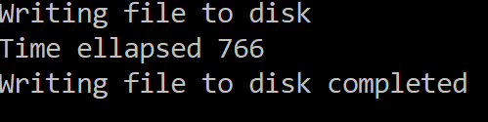

**Figure 7.3 – Output of FileUpload application with synchronization using Mutex**

If we go to the debug folder, we can see 5 files are created as shown in Figure 7.4 and content of the file would be the string that we passed.

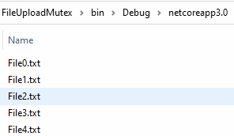

**Figure 7.4 – Files created in debug folder**

We can clearly see that there is no loss of data i.e. each file has 10 copies of the string that we passed and there is no run time exception. To see the benefit of Mutex let’s remove the mutex and run the application, our WriteTextAsync will look like below

private async Task WriteTextAsync(string fileName)

{

string text = $"Mutex is just like lock (full form mutually exclusive lock), however scope of locking spawns across processes i.e. " +

"if multiple instances of same process running mutex can be used to execute a code block by a single thread across processes.";

byte[] encoding = Encoding.Unicode.GetBytes(text);

await Task.Delay(1);

using (FileStream fs = new FileStream(fileName, FileMode.Append, FileAccess.Write, FileShare.None, bufferSize: 64, useAsync: true))

{

fs.Write(encoding, 0, encoding.Length);

}

}

Once we run the application now we will see below exception which is expected because there file is locked by one of the Thread for adding data and another thread parallelly tries to do same thing and raises an access exception.

System.IO.IOException

HResult=0x80070020

Message=The process cannot access the file '..\netcoreapp3.0\File0.txt' because it is being used by another process.

In this scenario we can use lock as well and will get same output, however it doesn’t makes sense to lock writing into a different file as lock will allow to writing into any file sequentially i.e. if currently a thread is writing into file1, lock will block writing into any other file also and that’s why a named mutex would be better here, considering the performance impact as code is blocked only for specific files. For testing purpose removing mutex and adding a lock would result in significant dip in performance which we can see in below output

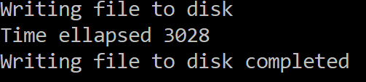

**Figure 7.4 – Output of FileUpload application with synchronization using lock**

So with this we can say lock and Mutex can be used to achieve synchronization however to lock a block of code or a resource across process named Mutex can be used.

**Some important facts about Mutex**

* Mutex has thread affinity, so the thread locking a resource, needs to unlock the resource i.e. locking and unlocking has to happen on same thread.
* Mutex can spawn across process.
* Lock is acquired by calling WaitOne method and released using ReleaseMutex method, however WaitOne can be called multiple times on same thread which is also know as recursive mutex, however we need to ensure that ReleaseMutex is called as many times as WaitOne is called.

In above example we can use WriteAsync instead of Write however that will result in an exception as Mutex has thread affinity which means thread calling waitone needs to call release method and since code after await would run on a different thread it would give an exception – “[Object synchronization method was called from an unsynchronized block of code. Exception on Mutex.Release()](https://stackoverflow.com/questions/9017521/object-synchronization-method-was-called-from-an-unsynchronized-block-of-code-e)”

To avoid this exception, we need to use advanced synchronization construct called AutoResetEvent which we will see later in this chapter.

**SpinLock (Exclusive)**

Spinlock is another form of exclusive lock which will synchronize access to shared resource however there isn’t thread context switching. So going back to all other locking techniques whenever a thread is blocked to access a shared resource it stops consuming any CPU cycles by giving up its processor time slice and causing a context switching in thread, same thing happens when thread is unblocked from blocked state. Although this context switching leads only to a few milliseconds delay but at large scale this is still an overhead.

So if there is a shared resource and needs locking for a very few milliseconds it would be better to not block all the threads that needs to access shared resources, but to just continue spinning which is something like calling a while loop until the shared resource is unblocked. This can be achieved in .net using a SpinLock class , let’s take AddBalanceToAccount method of BankAccount class this time we will use a SpinLock to synchronize access to accountBalance variable. We will first declare an object of SpinLock class that looks like this

SpinLock spinLock = new SpinLock();

Then use this lock to protect variables accountBalance and numberOfTransactions by calling Enter method of SpinLock class, this method accepts a Boolean variable which needs to be false before calling this method as once lock is acquired spinlock set this variable to true. This variable helps if there is any exception after lock is acquire, lock can be released safely. This is how our AddBalanceToAccount method will look like

async Task AddBalanceToAcccount(long amount)

{

await Task.Delay(1);

bool lockAcquired = false;

try

{

spinLock.Enter(ref lockAcquired);

accountBalance = accountBalance + amount;

numberOfTransactions = numberOfTransactions + 1;

}

finally

{

if (lockAcquired)

{

spinLock.Exit();

}

}

}

Modify AddMoneyToAccountAsync to include a Timer, it’s code will look like below

public async Task AddMoneyToAccountAsync()

{

Stopwatch timer = new Stopwatch();

timer.Start();

var tasks = new Task[99999];

for (int i = 1; i <= tasks.Length; i++)

{

tasks[i - 1] = AddBalanceToAcccount(i);

}

await Task.WhenAll(tasks);

Console.WriteLine($"Time taken - {timer.ElapsedMilliseconds}");

}

Once we run AddMoneyToAccountAsync output will look like below

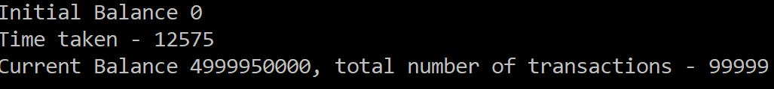

**Figure 7.5 – Output of using spinlock**

Just for testing purpose replacing spinlock with a lock and checking output we get output as shown in Figure 7.6 . Here we can see that time taken slightly goes up and that’s because there isn’t any context switching with spin lock

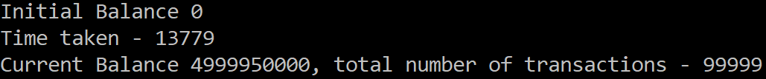

**Figure 7.6 – Output of using lock**

**Some important facts about spinlock**

* Use spinlock only for locking code that executes fast perhaps few microseconds i.e. a brief spinning is preferred over blocking
* Always prefer locks over spinlock as spinlock although consumes less times in some scenarios consume lot of CPU

In this section we have seen what spinlock is, why we need it and how we can implement it. In general SpinLock is more of internal concept that is used as part of some of the .Net classes especially slim versions of synchronization constructs.

**Semaphore (Non - Exclusive)**

Semaphore is a non-exclusive lock that supports synchronization by limiting the access to limited number of threads. So unlike mutex which allows only one thread to enter critical section semaphore allows set of threads to enter critical section, the number of threads that have access to shared resources is defined which creating semaphore. Semaphore is a non-exclusive lock and hence it should be used in situations where we need to lock a pool of resources for example in a client server scenario (where you own both client app and server APIs) say you want restrict number of calls your client app can make to your API concurrently from within a single instance, or something like thread pool or database connection semaphores are ideal fit.

In .Net semaphores can be created using [System.Threading.Semaphore](https://docs.microsoft.com/en-us/dotnet/api/system.threading.semaphore) class, an object of Semaphore class needs to be instantiated which has multiple constructors but 2 important parameters needs to be passed always

1. Initial number of entries
2. Maximum number of concurrent entries

So, a typically initialization will look like below

Semaphore semaphore = new Semaphore(0,3);

In this case we are telling initial concurrent requests allowed is 0 and will allow upto 3 concurrent threads after release i.e. in this case we are initializing semaphore however program has to wait until release is called at least once. If semaphore needs to enter semaphore immediately and allow maximum concurrency ideally both the parameters should have same value something like below

Semaphore semaphore = new Semaphore(3,3);

To acquire a semaphore we need to call WaitOne method of semaphore class and to release need to call Release method which accepts an optional integer to release semaphore that many number of times, if nothing is passed semaphore releases one thread. We will see this with a simple example of building water where water needs two Hydrogen threads and one Oxygen thread in this sequence. Restriction is that all the threads from one molecule bond before subsequent molecules from any other thread. We will take an input of series of strings a combination of ‘H’ and ‘O’ and handle accordingly. So, if input is HHHHOO output would be HHOHHO i.e. each character is processed by a thread and after second H program needs to wait for next O in the sequence to complete water molecule before processing other characters in sequence.

Will start with first creating Water class and we need two semaphores one for Hydrogen and another for Oxygen. Now since for every water molecule two Hydrogen threads are required we will initialize Hydrogen Semaphore with a maximum concurrent thread count of 2 and since Hydrogen thread can be processed as soon as it is created initial number of entries can be 0, so this will look like below

Semaphore semaphoreH = new Semaphore(2, 2);

Then we will create Oxygen semaphore which will have maximum concurrent thread count of 1 and since Oxygen thread always needs to be processed/released only after two Hydrogen threads initial concurrent requests should be 0 that is Oxygen thread needs to wait till any two Hydrogen threads are processed. With this Oxygen semaphore will look like below

Semaphore semaphoreO = new Semaphore(0, 1);

So, our class will look like below

public class Water

{

Semaphore semaphoreO = new Semaphore(0, 1);

Semaphore semaphoreH = new Semaphore(2, 2);

}

Now add two private methods to print Hydrogen and Oxygen like below

void ReleaseHydrogen()

{

Console.WriteLine("H");

}

void ReleaseOxygen()

{

Console.WriteLine("O");

}

Now we need two more methods to process Hydrogen and Oxygen threads and release each other accordingly, this is where we will use our semaphores -

* Hydrogen method will allow to enter two threads in critical section and will release Oxygen semaphore when two Hydrogen threads are processed, but won’t allow more than two Hydrogen threads to enter critical section until one Oxygen thread is processed
* Oxygen method will wait to Release Oxygen if two Hydrogen threads are processed and release Hydrogen semaphore twice or else will wait on Oxygen semaphore.

Both these methods will look like below

int hCount = 0;

public async Task HThread(Action releaseH)

{

await Task.Delay(1);

//Wait on Hydrogen thread, code after this will be blocked after processing two Hydrogen threads until one Oxygen thread is processed

semaphoreH.WaitOne();

releaseH();

hCount++;

if (hCount % 2 == 0) //For every two Hydrogen threads releasing Oxygen semaphore to process Oxygen method.

{

semaphoreO.Release();

}

}

public async Task OThread(Action releaseO)

{

await Task.Delay(1);

//Locking on Oxygen semaphore, this will allow to be processed only when 2 Hydrogen threads are processed or else will wait.

//Code after this is blocked until two Hydrogen threads are processed as initial concurrent threads for Oxygen semaphore is 0 (first parameter)

semaphoreO.WaitOne();

releaseO();

semaphoreH.Release(2); //Exiting Hydrogen semaphore twice, allowing two Hydrogen to be processed

}

Now let’s define method to build water in which we will loop through input sequence and initiate Hydrogen thread if input character is H and initiate Oxygen thread if input character is O

public async Task BuildWaterAsync(string input)

{

List<Task> tasks = new List<Task>();

foreach (char c in input)

{

switch (c)

{

case 'O':

tasks.Add(OThread(ReleaseOxygen));

break;

case 'H':

tasks.Add(HThread(ReleaseHydrogen));

break;

default:

break;

}

}

await Task.WhenAll(tasks);

}

Let’s consume this class in a simple console application and call BuildWaterAsync method, so create a console application add Water class to the app and replace main method with below code

static async Task Main(string[] args)

{

Water water = new Water();

while (true)

{

Console.WriteLine("Please enter sequence of Hydrogen and Oxygen molecules or e to Exit");

string input = Console.ReadLine();

if (input == "e")

break;

await water.BuildWaterAsync(input);

}

}

Once we run this code output will look below

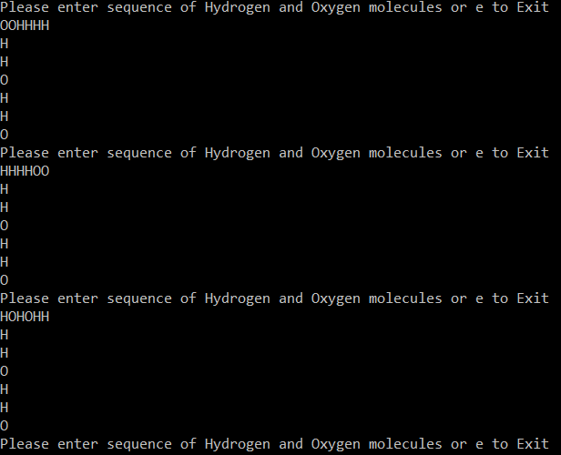

**Figure 7.7 – Output of build water application using semaphore**

In this sample we can clearly see how semaphore is helping to lock critical section with more than one threads and signaling on the availability of resources. Similarly, many classic synchronization problems like Dining Philosopher problem, producer-consumer problem, reader-writer problem can be solved using semaphores.

Note – The above example is built with assumption that user will always enter a combination that can be converted into one water molecule as intent is here is to understand semaphore. Further validation can be added to handle scenarios where there aren’t enough Hydrogen threads or Oxygen threads.

**Some important facts about semaphore**

* Semaphore doesn’t have thread affinity, so any thread call Release method, its application responsibility to release semaphore appropriately.
* Semaphores are usually used for signaling of resource availability, like a thread is available in thread pool.
* Semaphores can be named semaphores; these can be used to support across process synchronization.
* A typical scenario of Semaphore usage is a requirement where we want to limit concurrent database connections or in a multi core scenario to limit the number of concurrent threads executing a specific operation.

In this section we have seen what Semaphore is, why we need it and how to implement it. In next section we will see a lightweight version of Semaphore.

**SemaphoreSlim (Non - Exclusive)**

SemaphoreSlim is another class in System.Threading and is lightweight version to create Semaphores in C#. When we use System.Threading.Semaphore class to create a semaphore it internally uses Windows kernel semaphores which involves blocking , context switching of threads and also expensive kernel transition, however SemaphoreSlim implements spinning through spinwait and if it cannot acquire lock after spinning for a while(Microseconds) then it uses blocking to acquire lock. As discussed earlier that spinning for a very brief period of time is less expensive as compared to blocking hence SemaphoreSlim is good fit for such scenarios where the wait time to acquire critical section is less. Couple of other properties that SemaphoreSlim supports are

* To acquire a slot in SemaphoareSlim we need to call Wait method or WaitAsync method
* SemaphoreSlim doesn’t support named Semaphores so by default it’s always local Semaphore
* SemaphoreSlim has support for asyn methods like WaitAsync
* Since async methods are available SemaphoreSlim also allows cancellation token which means cancellation is allowed and at times can be useful to come out of deadlock.
* SemaphoreSlim has a constructor that supports initializing it with one parameter which is initial available slots and no upper limit. In such semaphores release method can be called any number of times and there won’t be any exception(SemaphoreFullException) thrown in such cases, it’s developer’s responsibility to call wait and release methods appropriately.
* SemaphoreSlim has CurrentCount property which tells the number of threads that can get a slot.
* Just like Semaphore, SemaphoreSlim is also thread agnostic.

Going back to our example if we use SemaphoreSlim we need to change initialization as below

SemaphoreSlim semaphoreH = new SemaphoreSlim(2, 2);

SemaphoreSlim semaphoreO = new SemaphoreSlim(0, 1);

Instead of WaitOne we will call WaitAsync and making use of CurrentCount our code will look like below

public async Task HThread(Action releaseH)

{

if (semaphoreH.CurrentCount == 0 && semaphoreO.CurrentCount == 1)

{

Console.WriteLine("Hydrogen is ready, waiting for Oxygen");

}

//Wait on Hydrogen thread, code after this will be blocked after processing two Hydrogen threads until one Oxygen thread is processed

await semaphoreH.WaitAsync();

releaseH();

hCount++;

if (hCount % 2 == 0) //For every two Hydrogen threads releasing Oxygen semaphore to process Oxygen method.

{

semaphoreO.Release();

}

}

public async Task OThread(Action releaseO)

{

if (semaphoreH.CurrentCount > 0 && semaphoreO.CurrentCount == 0)

{

Console.WriteLine("Oxygen is ready, waiting for Hydrogen");

}

//Locking on Oxygen semaphore, this will allow to be processed only when 2 Hydrogen threads are processed or else will wait.

//Code after this is blocked until two Hydrogen threads are processed as initial concurrent threads for Oxygen semaphore is 0 (first parameter)

await semaphoreO.WaitAsync();

releaseO();

semaphoreH.Release(2); //Exiting Hydrogen semaphore twice, allowing two Hydrogen to be processed

}

Output for with SemaphoreSlim will have additional information as we now can tell when Hydrogen is waiting on Oxygen or vice-versa. Once we run this application output will be as shown in Figure 7.8

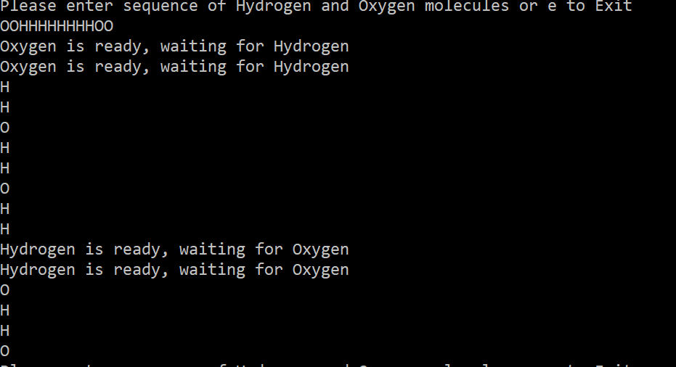

**Figure 7.8 – Output of build water application using SemaphoreSlim**

As such there is no hard and fast rule on what to use when but mostly by rule of elimination where if we want cross process semaphore use Semaphore class, if we want lightweight semaphore for synchronization of a resource that is held for a very shorter period of time go for SemaphoreSlim.

**Reader/Writer locks (Non – Exclusive)**

Often, it’s a case where we use exclusive locks for a shared resource which is recommended practice and also guarantees of proper synchronization of data, however there could be scenarios where a resource just red multiple times with periodic updates. Using lock in such scenarios will ensure synchronization during concurrent access however it will slow down the application as two threads that just wanted to read data will be processed sequentially. Such cases can be better handled using ReaderWriter locks which allows a shared resource to be accessed by multiple threads that wanted to perform read operation and allows single thread for write operation.

Taking an analogy of a teacher writing on blackboard and students copying it

* While teacher is writing on the blackboard none of the students can see what is on the blackboard (Single write)
* Teacher won’t erase content on black board until last student finishes copying the content (Multiple reads and write thread in queue until last read thread has released the lock)

A ReaderWriter lock can be achieved in C# either by creating an object of System.Threading.ReaderWriterLock or System.Threading.ReaderWriterLockSlim class. ReaderWriterLockSlim is a thinner version of ReaderWriterLock which lesser memory footprint and better performing. Both these classes have methods -

* To acquire read lock which can be called by multiple threads – AcquireReaderLock /EnterReadLock
* To release read lock acquired by a thread (ReadWriteLocks have thread affinity so same thread that acquired lock needs to release the lock, this is applicable for both read and write locks) – ReleaseReaderLock/ExitReadLock
* To acquire write lock – AcquireWriterLock/EnterWriteLock
* To release write lock – ReleaseWriteLock/ExitWriteLock
* To acquire an upgradeable lock. An upgradable lock helps in acquiring a read lock and then upgrade to write lock based on a condition for example an upsert scenario. This can be normally achieved by acquiring a read lock, check if data is present, if not release read lock and then acquire a write lock. However, state of the shared resource may not remain same between releasing read lock and acquiring write lock hence it is preferable to use upgradeable lock.

Let’s see this with a simple example of writing data into file where we simulate around 30 threads with multiple reads and periodic update. Let’s create a console application and create a new public class FileWrite, create an instance of ReaderWriterLockSlim and also add a timer that will be used to get the execution time, our class will look like below

public class FileWrite

{

Stopwatch timer; //To compare performance with Monitor

public FileWrite()

{

timer = new Stopwatch();

timer.Start();

}

const string fileName = "SampleReadLock.txt";

ReaderWriterLockSlim readerWriterLockSlim = new ReaderWriterLockSlim();

}

Add two methods

private void ReadFile() – A method that reads data from file, we will lock the read operation using EnterReadLock and ExitReadLock method of ReaderWriteLock so as to avoid trying to read file when it is open for writing data (If we do not lock the read operation FileStream will throw System.IO.IOException -The process cannot access the file) . This method will look like below

private void ReadFile()

{

if (File.Exists(fileName))

{

readerWriterLockSlim.EnterReadLock();

using (FileStream fs = new FileStream(fileName, FileMode.Open, FileAccess.Read, FileShare.Read, 2048, useAsync: true))

{

using (System.IO.StreamReader rdr = new System.IO.StreamReader(fs))

{

Thread.Sleep(500); //Used to perform timer calculation,

Console.WriteLine(rdr.ReadToEnd());

}

}

readerWriterLockSlim.ExitReadLock();

}

}

private void WriteFile(int lineNumber) – A method that writes into file but before writing into file acquires a ReaderWriterLock using EnterWriteLock and ExitWriteLock. This method implementation will look below.

private void WriteFile(int lineNumber)

{

readerWriterLockSlim.EnterWriteLock();

string text = $"Line {lineNumber} ReadWriteLock" + Environment.NewLine;

byte[] encoding = Encoding.ASCII.GetBytes(text);

using (FileStream fs = new FileStream(fileName, FileMode.Append, FileAccess.Write, FileShare.Write, 2048, useAsync: true))

{

fs.Write(encoding, 0, encoding.Length);

}

readerWriterLockSlim.ExitWriteLock();

}

Now add method that will write into file if text is present else display so primarily an upsert operation. This method will make use of EnterUpgradeableReadLock which can be used to upgrade to write lock conditionally. This method implementation will look below

private void ReadorUpdateFile()

{

string fileContent = String.Empty;

if (File.Exists(fileName))

{

readerWriterLockSlim.EnterUpgradeableReadLock();

//First read the contents and if specific content exists then print on console else write into file

using (FileStream fs = new FileStream(fileName, FileMode.Open, FileAccess.Read, FileShare.Read, 2048, useAsync: true))

{

using (System.IO.StreamReader rdr = new System.IO.StreamReader(fs))

{

fileContent = rdr.ReadToEnd();

}

}

if (!(fileContent.Contains("Line 15")))

{

readerWriterLockSlim.EnterWriteLock();

using (FileStream fswrite = new FileStream(fileName, FileMode.Append, FileAccess.Write, FileShare.Write, 2048, useAsync: true))

{

byte[] encoding = Encoding.ASCII.GetBytes($"Line 15 ReadWriteLock" + Environment.NewLine);

fswrite.Write(encoding, 0, encoding.Length);

}

readerWriterLockSlim.ExitWriteLock();

}

else

{

Thread.Sleep(500); //Used to perform timer calculation,

Console.WriteLine(fileContent);

}

readerWriterLockSlim.ExitUpgradeableReadLock();

}

}

Let’s add another method to call these methods, let’s call it PerformFileOperation. The purpose of this method is to simulate around 30 parallel requests and primarily calling ReadFile and conditionally calls WriteFile, ReadorUpdateFile methods

public async Task PerformFileOperation()

{

var tasks = new Task[31];

for (int i = 0; i < tasks.Length; i++)

{

if (i % 10 == 0) //Calling write every tenth time

{

tasks[i] = Task.Run(() => WriteFile(i + 1));

Thread.Sleep(1000); //Used to perform timer calculation

}

else if (i == 15 || i == 21) //Calling upsert twice

{

tasks[i] = Task.Run(() => ReadorUpdateFile());

}

else //Calling read most of the time

{

tasks[i] = Task.Run(() => ReadFile());

}

}

await Task.WhenAll(tasks);

Console.WriteLine($"Time elapsed {timer.ElapsedMilliseconds}"); //Displaying time taken for execution

readerWriterLockSlim.Dispose();

}

Let’s instantiate this class in our main method and call PerformFileOperation method to read from a file and write/update into the same file conditionally. Main method will look below

static async Task Main(string[] args)

{

Console.WriteLine("Writing file to disk");

FileWrite fileupload = new FileWrite();

await fileupload.PerformFileOperation();

Console.WriteLine("Writing file to disk completed");

Console.Read();

}

Once we run this application

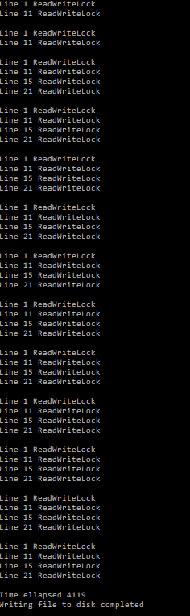

**Figure 7.9 – Output of file read application using ReaderWriteLockSlim**

Now let’s remove ReaderWriteLock and replace synchronization mechanism with Lock and run the application we noticed that output remains same however execution time is much higher (almost 3 times) and we know that is expected because Lock won’t allow multiple threads concurrently. So, ReaderWriteLock is an effective synchronization mechanism for a shared resource when there are many reads but periodic updates.

**Some important facts about reader/write locks**

* ReaderWriteLocks allows multiple read, one exclusive write lock.
* Among multiple read one can be upgraded to write lock
* ReaderWriteLock has thread affinity

In this section we have seen what ReaderWriteLocks is, why we need it and how to implement it. In next section we will see a what is thread signaling, how to implement it and specific scenarios where thread signaling is helpful.

**Signaling constructs**

Signaling constructs are the synchronization primitives available in C# that help in signaling a thread to wait or proceed based on a notification. A simple example would be Thread.Join where say thread X calling join method on thread Y will wait until thread Y is completed. Other signaling constructs that are available in C# are AutoResetEvent, ManualResetEvent/ManualResetEventSlim, CountdownEvent and Barrier class. C# provide an EvetWaitHandle class that is used for thread synchronization and AutoResetEvent, ManualResetEvent implements this class. A simple comparison of these constructs is as following

|  |  |
| --- | --- |
| **Signaling construct** | **Usage** |
| AutoResetEvent | Allows to unblock a thread (or a thread once) through signaling |
| ManualResetEvent/ManualResetEvenSlim | Allows to unblock all the threads (or a thread indefinitely) through signaling and blocks only after manually resetting signaling status through Reset method |
| CountdownEvent | Allows to unblock a thread after it receives a predefined number of signals |
| Barrier | Barrier allows threads to execute a piece of code parallelly and wait till all the threads have completed execution of that code with a post execution phase. |

**Table 7.1 – Comparison of Signaling constructs**

Let us deep dive into each of these constructs in next section

**AutoResetEvent**

AutoResetEvent like a toll gate where only one car is allowed at a time and each car needs access to go through the gate. AutoResetEvent class helps in creating a signaling construct which allows sending a signal so as to unblock a blocked/waiting thread and immediately reset the signals which means any subsequent thread will continue to wait in queue until next signal is received.

An AutoResetEvent is instantiated by its constructor something like this

AutoResetEvent event_1 = new AutoResetEvent(false);

Parameter to this constructor signifies if the event is already signaled or non-signaled i.e. true to signal which means one thread can proceed processing (tollgate is by default open for one car) and parameter is passed as false thread will wait to receive a signal. Blocking a thread is done by calling WaitOne() and releasing/signaling one thread is done by calling Set() method. Let’s look at this with a simple example of stock trading where a stock needs to be purchased when it reaches a specific price, we will use 2 threads here

* One to take input from user on the price that stock needs to be purchased
* One to randomize the current stocks price and see if it matches with user input and place order

Once user inputs stock buy price, to successfully complete the order that thread (waiting thread) will continue to wait till there is a match in current stock price. Now since matching is a complex process we will run on a separate thread. Once there is a match a signal (Signaling thread) is sent to complete the order. We will use AutoResetEvent to handle this signaling across threads Let’s create a class called StockTrading as following

public class StockTrading

{

AutoResetEvent autoResetEvent = new AutoResetEvent(false);

public int currentStockPriceOfXYZ { get; set; } //Holds current stock price

public int buyPriceofXYZ { get; set; } //Buy price of stocks

public bool StockPurchased { get; set; } //Flag that is set to true once order is successful

public StockTrading(bool stockPurchased)

{

this.StockPurchased = stockPurchased;

}

}

Add two methods

* PlaceOrder() - one to place order and will wait for signal from below method to complete the order/
* ValidatePrice() - one to validate stock price with buy price and signal according. This method is called every time there is change in stock price.

public void PlaceOrder()

{

Console.WriteLine("Enter price at which you want to buy XYZ (minimum 1, maximum 5)");

buyPriceofXYZ = Convert.ToInt32(Console.ReadLine());

this.StockPurchased = false;

autoResetEvent.WaitOne(); //Wait until receives signal from price validation

Console.WriteLine($"Stock purchased at buy price of {buyPriceofXYZ}");

Console.WriteLine("One stock order is completed; press enter to exit");

this.StockPurchased = true;

Console.ReadLine();

}

public void ValidatePrice()

{

if (this.buyPriceofXYZ == this.currentStockPriceOfXYZ)

{

Console.WriteLine($"Current stock price of {this.currentStockPriceOfXYZ} is matching with buy price of {this.buyPriceofXYZ}");

autoResetEvent.Set(); //Signal first thread waiting in queue to execute

}

else if(!this.StockPurchased)

{

Console.WriteLine($"Current stock price of {this.currentStockPriceOfXYZ} is not matching with buy price of {this.buyPriceofXYZ}");

}

}

Let’s add our class to a console application and consume it in our main application as following

static void Main(string[] args)

{

Console.WriteLine("Please enter buy price of stock XYZ");

StockTrading stockTrading = new StockTrading(false);

//Thread to place order

Thread placeOrder = new Thread(stockTrading.PlaceOrder);

placeOrder.Start();

//Thread that checks for current price and completes order

Thread validatePrice = new Thread(() =>

{

Random randomCurrentPriceofStock = new Random();

while (!stockTrading.StockPurchased)

{

stockTrading.currentStockPriceOfXYZ = randomCurrentPriceofStock.Next(1, 5);

stockTrading.ValidatePrice();

Thread.Sleep(1000); // Wait for input before execuiting next iteration or else screen will overflow

}

});

validatePrice.Start();

}

Here we are creating two threads to place order and validate price, validate price thread needs to be iterated as stock prices changes. Once we run this application output will look like below

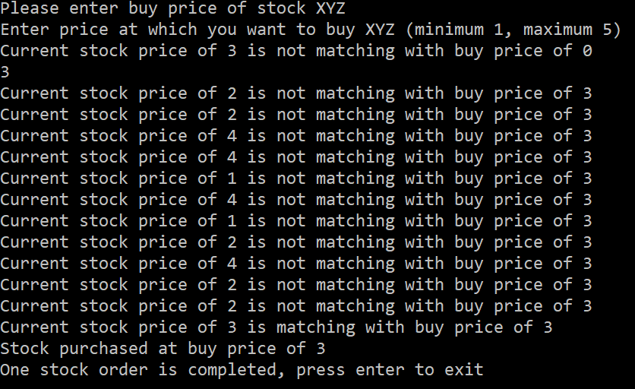

**Figure 7.10 – Output of stock trading application using AutoResetEvent**

As you can see due to calling of WaitOne, PlaceOrder() will wait until Set() is called, in our case we are calling it once purchase price matches with stock price.

**Some important facts about AutoResetEvent**

* Calling Set multiple times will not cause an exception even if there aren’t any waiting threads, all it does is not block the first thread that is calling WaitOne but subsequent threads will be blocked until another thread is calling Set. For example, in below console app

private static AutoResetEvent autoResetEvent = new AutoResetEvent(false);

static void Main()

{

for (int x = 0; x < 3; x++)

{

Thread thread = new Thread(ThreadProcecss);

thread.Name = "Thread " + x;

thread.Start();

}

Console.WriteLine("Press Enter to release blocked threads");

Console.ReadLine();

autoResetEvent.Set(); //Thread 0 is released

autoResetEvent.Set(); //Thread 1 is released

autoResetEvent.Set(); //Thread 2 is released

autoResetEvent.Set(); //Thread 3 won’t be blocked

autoResetEvent.Set(); // This is of no use as any set call after above line will be nullified once a thread goes through

autoResetEvent.Set(); // This is of no use as any set call after above line will be nullified once a thread goes through

for (int x = 3; x < 7; x++)

{

Thread thread = new Thread(ThreadProcecss);

thread.Name = "Thread " + x;

thread.Start();

}

}

static void ThreadProcecss()

{

string threadName = Thread.CurrentThread.Name;

Console.WriteLine($"{threadName} waits on AutoResetEvent.");

autoResetEvent.WaitOne();

Console.WriteLine($"{threadName} is released from AutoResetEvent...");

}

Once we run this code, output will look like below

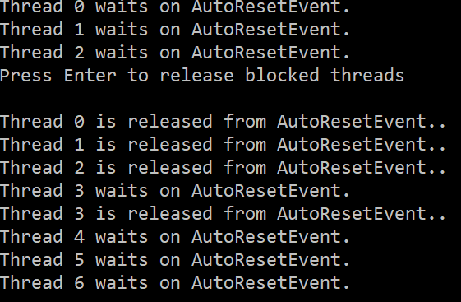

**Figure 7.11 – Output of console application using AutoResetEvent with multiple call to Set()**

* As AutoResetEvent inherits from EventHandle it can also be created like below

EventWaitHandle autoResetEvent = new EventWaitHandle(false, EventResetMode.AutoReset);

* AutoResetEvent is thread agnostic as it is more of signaling construct

In this section we have seen what AutoResetEvent is, why we need it and how to implement it. In next section we will see a another signaling construct known as ManualResetEvent which is very similar to AutoResetEvent

**ManualResetEvent/ ManualResetEventSlim**

ManualResetEvent is another signaling construct like AutoResetEvent which can be used for by threads to signal a different thread. The difference between AutoResetEvent and ManualResetEvent is that it has ability to unblock all the blocked threads until it is manually reset. Taking an analogy ManualResetEvent is just like a gate which is when opened allows all the people waiting outside to come in until is gate is manually closed.

A printer can also be a good example of ManualResetEvent that is initialized in signaled state where all the print jobs that come to printer are executed immediately until you run out of paper or ink and that’s where all the ManualResetEvent is non-signaled and all the printing jobs are paused. Moment we fill the ink or add paper ManualResetEvent is signaled and all the printing jobs are continued until something again blocks them.

ManualResetEvent has 3 methods to achieve signaling

* Set – Set method is called by a one thread to send signal to all the waiting threads. Unlike AutoResetEvent signal is received by all waiting threads
* WaitOne/Wait – Any thread that calls WaitOne/Wait is blocked until it is signaled, if a thread has already received signaled then none of threads will be blocked
* Reset – This method is used to reset ManualResetEvent to non-signaled state . If a call to Set is not followed by call to Reset all the threads calling WaitOne aren’t blocked until Reset is called.

ManualResetEvent can be constructed by calling the ManualResetEvent constructor which accepts a Boolean value like below

ManualResetEvent manulResetEvent = new ManualResetEvent(false);

ManualResetEventSlim manulResetEvent = new ManualResetEventSlim(false);

The Boolean flag has same impact like in AutoResetEvent i.e. if initialized with true it won’t block any code by default until ManualResetEvent is reset (call Reset) and false means threads will be blocked as soon as they see a call to WaitOne method of ManualResetEvent. ManualResetEvent can also be constructed through EventWaitHandle

EventWaitHandle manulResetEvent = new EventWaitHandle(false, EventResetMode.ManualReset);

ManualResetEvent also has a lightweight class ManualResetEventSlim, this one doesn’t use operating system objects (kernel objects) directly and uses spinning for a shorter period before blocking and then finally fall back to kernel objects hence is much faster and lighter than ManualResetEvent. Let’s use the stock example we have used for AutoResetEvent and this time say we have to allow multiple threads to successfully place order if there is a specific match, so it can be one or more than one threads that can match a particular stock order. Let’s start by modifying StockTrading class by adding an object of ManualResetEventSlim

public ManualResetEventSlim manualResetEvent = new ManualResetEventSlim(false);

Now modify PlaceOrder() to call Wait instead of WaitOne so that our method looks like below

public void PlaceOrder(int threadId, int buyPrice)

{

buyPriceofXYZ = buyPrice;

this.StockPurchased = false;

manualResetEvent.Wait(); //Wait until receives signal from price validation

Console.WriteLine($"Stock purchased at buy price of {buyPriceofXYZ}, Stock order {threadId} is completed");

this.StockPurchased = true;

}

Update ValidatePrice() method with ManualResetEvent variable, so our method looks like below

public void ValidatePrice()

{

if (this.buyPriceofXYZ == this.currentStockPriceOfXYZ)

{

Console.WriteLine($"Current stock price of {this.currentStockPriceOfXYZ} is matching with buy price of {this.buyPriceofXYZ}");

manualResetEvent.Set(); //Signal first thread waiting in queue to execute

}

else if(!this.StockPurchased)

{

Console.WriteLine($"Current stock price of {this.currentStockPriceOfXYZ} is not matching with buy price of {this.buyPriceofXYZ}");

}

}

Now while consuming we will create multiple place orders with same buy price and expectation is that all the orders are placed. So, create a console application and add StockTrading class, in the main method add logic to create multiple threads for place order and then another thread calling ValidatePrice to complete order. With this our main method will look like below

static void Main(string[] args)

{

Console.WriteLine("Please enter buy price of stock XYZ");

StockTrading stockTrading = new StockTrading(false);

Console.WriteLine("Enter price at which you want to buy XYZ (minimum 1, maximum 5)");

int buyPrice = Convert.ToInt32(Console.ReadLine());

//Multiple threads to place 3 orders

for (int i = 0; i < 3; i++)

{

Thread placeOrder = new Thread(() => stockTrading.PlaceOrder(i, buyPrice));

Thread.Sleep(1000);

placeOrder.Start();

}

Console.WriteLine("3 orders placed; press enter to start stock price matching!!");

Console.ReadLine();

//Thread that checks for current price and completes order

Thread validatePrice = new Thread(() =>

{

Random randomCurrentPriceofStock = new Random();

while (!stockTrading.StockPurchased)

{

stockTrading.currentStockPriceOfXYZ = randomCurrentPriceofStock.Next(1, 5);

stockTrading.ValidatePrice();

Thread.Sleep(1000); // Wait for input before execuiting next iteration or else screen will overflow

}

});

validatePrice.Start();

Console.ReadLine();

}

If we run code now we will see that all the orders successfully placed once there is a price matching in ValidatePrice() method, however let’s create some more orders after initial set of orders and call ValidatePrice method to complete the order. So, add below code to main method after first set of orders

//Resetting ManualResetEvent to non-signaled state so that any subsequent orders are blocked (threads)

//if this is not called call to .Wait method won't be blocked (Gate is open till Reset is called)

stockTrading.manualResetEvent.Reset();

Console.WriteLine("\nPlease enter buy price of stock XYZ");

buyPrice = Convert.ToInt32(Console.ReadLine());

//Multiple thread to place 2 more orders

for (int i = 3; i < 5; i++)

{

Thread placeOrder = new Thread(() => stockTrading.PlaceOrder(i, buyPrice));

Thread.Sleep(1000);

placeOrder.Start();

}

Console.WriteLine("2 orders placed; press enter to start stock price matching!!");

Console.ReadLine();

//Thread that checks for current price and completes order

validatePrice = new Thread(() =>

{

Random randomCurrentPriceofStock = new Random();

while (!stockTrading.StockPurchased)

{

stockTrading.currentStockPriceOfXYZ = randomCurrentPriceofStock.Next(1, 5);

stockTrading.ValidatePrice();

Thread.Sleep(1000); // Wait for input before execuiting next iteration or else screen will overflow

}

});

validatePrice.Start();

Console.ReadLine();

So, if you noticed before placing new orders we calling Reset method of ManualResetEvent which will ensure that it is reset back to non-signaled state and any subsequent calls to Wait() will be blocked until they receive signal. We will run this application now

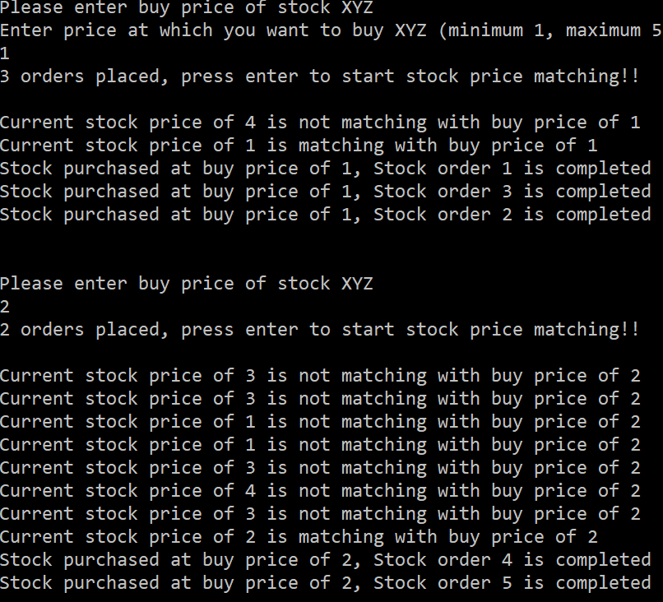

**Figure 7.12 – Output of stock trading application using ManualResetEvent**

If we do not call Reset between orders, they will complete without any price matching. So, a ManualResetEvent is helpful in scenarios where all threads need to be unblocked based on an event. There is another signaling construct CountdownEvent which is exact opposite of this i.e. multiple threads will send a signal for one signal to process, we will see this in next section.

**CountdownEvent**

CountdownEvent is signaling construct that waits for n number of threads before sending signal to blocked threads. CountdownEvent does this by maintaining a count which is used to signal to a waiting thread once it reaches zero.

Taking an analogy of a bus service which can only leave a station only after all the passengers on boarded the bus (assuming bus service wants to maximize profit hence not sticking to time but gives more importance for all passengers to on board), driver will wait till last passenger onboarded. Here passengers are threads, bus is the shared resource and driver is the waiting thread that waits for all threads to complete.

CountdownEvent is initialized by its constructor which takes integer as its parameter, this integer input to constructor is what decides the number of threads that needs to be completed before sending signal to waiting thread. Initialization will look like below –

CountdownEvent fileManager = new CountdownEvent(10);

In this case waiting thread will wait till 10 other threads are processed. To achieve this CountdownEvent has following important methods –

* Wait – Call to this method will make the thread to wait until signal is received by CountdownEvent i.e. typically n number of threads calling Signal method.
* Signal – This method decrements the currentcount of CountdownEvent, when currentcount is zero waiting thread will receive signal
* Reset – Reset’s currentcount of CoutdownEvent to the value CountdownEvent is initialized with.

Let us see this with a simple file download simulator example where we will simulate file downloading and downloading is broken into multiple parallel requests and finally when all the parallel requests are completed parent thread is notified to merge chunks into single file. Let us create a class called FileDownloadSimulator which will have a CountdownEvent a ConcurrentDictionary

public class FileDownloadSimulator

{

CountdownEvent fileManager;

ConcurrentDictionary<int, string> tempFileResponse = new ConcurrentDictionary<int, string>();

public FileDownloadSimulator(int numberOFThreadsProcessingFileDownload)

{

fileManager = new CountdownEvent(numberOFThreadsProcessingFileDownload);

}

}

Let us add two methods to this class

* SimulateFileDownload – This method will simulate file download and call Signal() method of CountdownEvent. Since this simulator we will just add a text to the concurrent dictionary.
* FileMerge – This method will merge all the chunks into one single file and print. This method must wait till all the chunks are downloaded

These methods will look like below

public void SimulateFileDownload(int threadID)

{

Thread.Sleep(200);

tempFileResponse.TryAdd(threadID, $"Line {threadID + 1} of file.\t");

Console.WriteLine($"Finished processing {threadID}");

fileManager.Signal();

}

public string FileMerge()

{

fileManager.Wait();

Console.WriteLine("Finished Processing,priting contents");

StringBuilder fileContents = new StringBuilder();

for (int i =0;i< tempFileResponse.Count;i++)

{

string output;

tempFileResponse.TryGetValue(i, out output);

fileContents.Append(output);

}

return fileContents.ToString();

}

Now create a console application and add this class to our console application, also simulate parallel threads that will call SimulateFileDownload method and then eventually FileMerge method. With this our main class will look like below

static void Main(string[] args)

{

Console.WriteLine("Welcome to file downloader, please enter number of parallel threads file download needs to occur");

int numberOFThreadsProcessingFileDownload = Convert.ToInt32(Console.ReadLine());

FileDownloadSimulator fileDownloadSimulator = new FileDownloadSimulator(numberOFThreadsProcessingFileDownload);

for (int i=0;i< numberOFThreadsProcessingFileDownload; i++)

{

int captured = i;

Thread t = new Thread(() => fileDownloadSimulator.SimulateFileDownload(captured));

t.Start();

}

Console.WriteLine(fileDownloadSimulator.FileMerge());

Console.ReadLine();

}

Once we run this application will see output based on the input on number of parallel chunks, in this case we gave an input of 20. So, that will cause CountdownEvent to Wait till 20 threads are processed (20 times Signal method is called continuously)

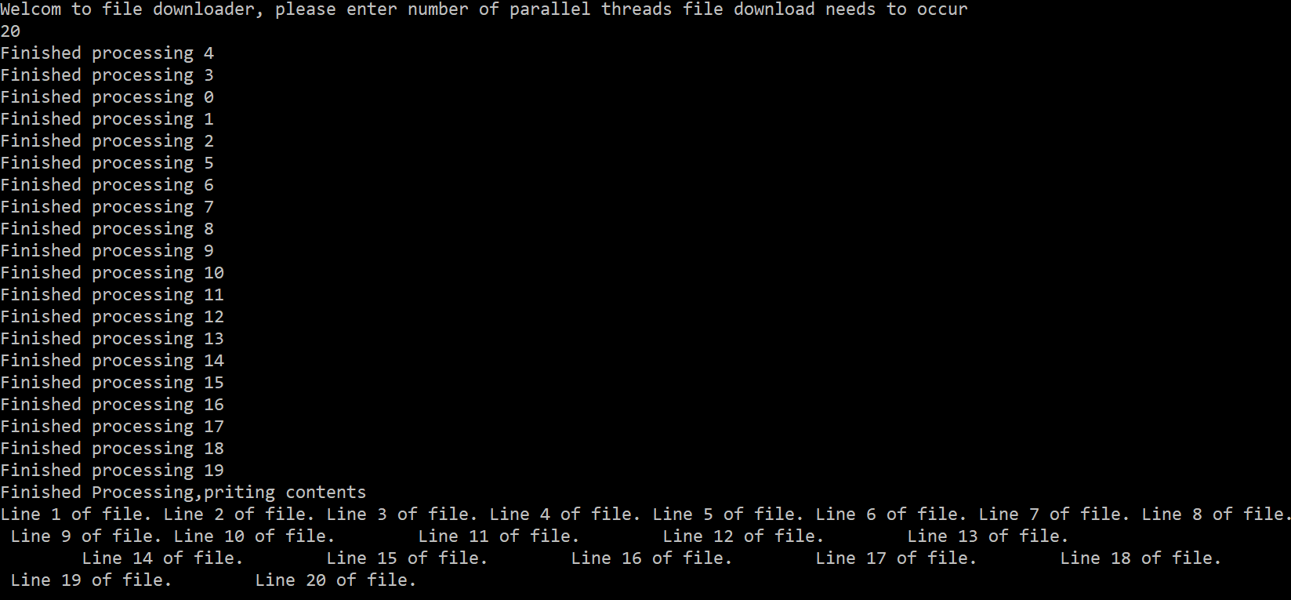

**Figure 7.13 – Output of parallel file download using CountdownEvent**

So, this is a simple scenario where we can take advantage CountdownEvent for signaling between threads. This can be further scaled up to a real time API call to download a file to speed up file download or another example could be multiple threads making DB calls and parent thread is waiting on all these DB threads to consolidate (or apply business rules) before sending response back to the client.

**Barrier classes**

Barrier is a signaling construct that helps in threads to wait for each other primarily at a specific point. So, it acts like a barrier where each thread/task executes a piece of code and then waits at a specific point for all the other threads/tasks to finish their execution, once all the threads reach specific waiting point threads are allowed to proceed with subsequent execution, this also helps in scenarios where there are multiple phases and all threads needs to complete each phase before they can start on the next phase. Barrier also supports post phase execution which will be executed after all threads complete sending in every phase. A pictorial representation would look like below

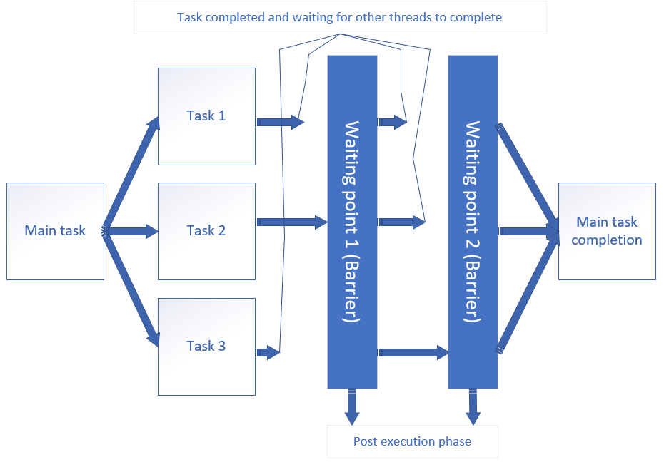

**Figure 7.14 – Barrier splint into 3 tasks and going through 2 phases**

Let’s see this with a simple example where we are building a system to check whether a person is eligible for home loan, decision for eligibility is decided by credit score from multiple sources and if credit score is good from each source then will move to next phase where we look some additional social sources and then approve loan accordingly. Let us start with creating a HomeLoan class that has a Barrier object and couple of Boolean fields to track various activities during verification. A parametrized constructor of this class is used to initialize Barrier with number of participants set to input parameter and a post execution phase, with this our class will look like below

public class HomeLoan

{

const int minScore = 150;

const int maxScore = 1000;

Barrier barrier;

public bool HomeLoanStatus { get; set; }

bool creditScoreStatus, socialScoreStatus;

public HomeLoan(int numberOfParticipants)

{

barrier = new Barrier(numberOfParticipants, (myBarrier) =>

{

Console.WriteLine($"========================================================");

Console.WriteLine($"Phase {barrier.CurrentPhaseNumber} finished for all sources");

Console.WriteLine($"========================================================");

});

this.HomeLoanStatus = creditScoreStatus = socialScoreStatus = true;

}

}

Add three method to this class as explained below

* GetCreditScore and GetSocialScore – Both of them simulates returning a random number which will be used as credit score and social score

Definition of these methods will look like below

int GetCreditScore()

{

Random rnd = new Random();

return rnd.Next(minScore, maxScore);

}

int GetSocialScore()

{

Random rnd = new Random();

return rnd.Next(minScore, maxScore);

}

* HomeanAnalyzerAsync(string sourceName) – This method will be split into 2 phases
  + Phase 0 – Credit score evaluation
  + Phase 1 – Social score evaluation, this phase checks social score only if credit score is above certain number or else will exit and set home loan status accordingly

Definition of this methods will look like below

public async Task HomeanAnalyzerAsync(string sourceName)

{

await Task.Factory.StartNew(() =>

{

// Start of phase 0

Console.WriteLine($"Credit score evaluation, phase {barrier.CurrentPhaseNumber}, from source {sourceName} started");

int creditScore;

creditScore = GetCreditScore();

if (creditScore < 200 && creditScoreStatus)

{

creditScoreStatus = false;

}

// Signal the barrier

barrier.SignalAndWait();

// start of phase 1

Console.WriteLine($"Social score evaluation, phase {barrier.CurrentPhaseNumber}, from source {sourceName} started");

if (!creditScoreStatus)

{

Console.WriteLine($"Bad credit score from source {sourceName}");

this.HomeLoanStatus = false;

}

else

{

int socialScore;

socialScore = GetSocialScore();

if (socialScore < 200 && socialScoreStatus)

{

Console.WriteLine($"Bad social score from source {sourceName}");

socialScoreStatus = false;

this.HomeLoanStatus = false;

}

}

//signal the barrier

barrier.SignalAndWait();

});

}

Create a console application and add this class. In the main method take input from user on the number of sources that is going to be used for home loan evaluation and create tasks for each source to execute them parallelly by calling HomeanAnalyzerAsync method. Finally print the output of home loan approval/rejection. Our Main method will look like below

static async Task Main(string[] args)

{

Console.WriteLine("Welcome to home loan analyzer, please enter number of sources needed for verification");

int numberofSources = Convert.ToInt32(Console.ReadLine());

Task[] tasks = new Task[numberofSources];

HomeLoan homeLoan = new HomeLoan(numberofSources);

for (int i=0;i<numberofSources;i++)

{

tasks[i] = homeLoan.HomeanAnalyzerAsync(i.ToString());

}

await Task.WhenAll(tasks);

if (homeLoan.HomeLoanStatus)

Console.WriteLine("Home loan approved");

else

Console.WriteLine("Home loan rejected");

Console.ReadLine();

}

Once we run this application output will look like below

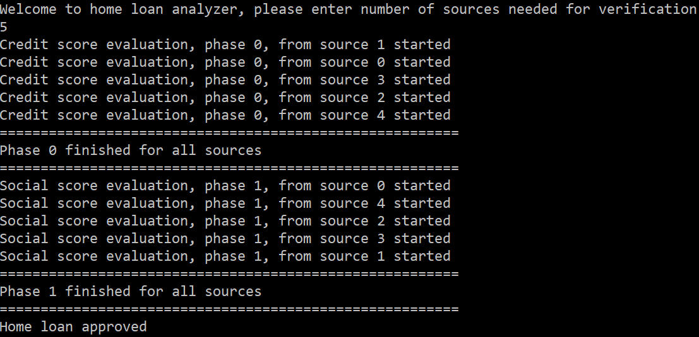

**Figure 7.15 – Home loan analyzer using Barrier**

**Some important facts about Barrier**

* All threads wait on each other including main thread.
* Barrier is reused i.e. SignalandWait can be called based on the number phases and is irrespective of the value Barrier is initialized with.
* Any post phase exception in results in BarrierPostPhaseException.

In this section we discussed about a signaling construct known as Barrier and scenarios where it is useful. Here we have seen how Barrier can be used in a situation where we have large processing system and multiple phases and how parallel threads can be used and synchronized. In next section we will see any other synchronization context that are available in .Net.

**Wait and Pulse**

Wait and Pulse are methods available in Monitor class that can be used to build a custom signaling construct i.e. If we do not want to use any of the available constructs and build our own class that can be used for in thread signaling then Wait and Pulse methods are way to go.

* Wait method blocks the thread
* Pulse method sends a signal to the thread that is blocked, Pulse can unblock one thread, something like in AutoResetEvent
* PulseAll sends signal to all blocked threads, so this can be used to release all threads, something like in ManualResetEvent

If we are building custom signaling construct then we need to handle all the flags that are needed for thread signaling like current count, reset, initial state etc. Also, we need to use some locking construct to protect shared variables in such class. Although Wait and Pulse can be used to build our own custom signaling construct we should try to use the ones given by .Net and if still they are not solving the problem then go for Wait and Pulse.

This concludes signaling constructs where we have seen usage of AutoResetEvent, ManualResetEvent, CountdownEvent, Barrier and finally Wait/Pulse. Apart from these there are some more synchronization constructs available in .Net which we will see briefly in next section.

**Interlocked class**

Interlocked class is a static class that has methods available to achieve non-blocking synchronization. This is typically used in scenarios where shared variable has increments or decrements and needs to be locked during concurrency, so instead of wrapping that variable with a lock statement we can use Interlocked class to modify values of that variable. Usage of Interlocked class is much easier, and it is faster as compared to locks. It has following primary methods to modify a variable

Increment – Used to increment value of variable. For example –

int x = 0;

Interlocked.Increment(ref x); //Value of x changes to 1

Decrement – Used to decrement value of variable.

Exchange – Used to assign a value to variable

int x = 0;

Interlocked.Exchange(ref x, 10); // Value of x is 10 now

CompareExchange – This method takes 3 parameters, compares first and last parameter and if both are same assigns second parameter to first parameter

int x = 10;

Interlocked.CompareExchange(ref x, 20, 10); // Value of x is 20 now

The good thing about interlocked is it helps in achieving atomicity i.e. it optimizes CPU instructions and execute them as one single instruction (i.e. all instructions executed in one single go without context switching) and is mostly used in tandem with other synchronization constructs to achieve simple increment, decrement or assignment.

**Volatile class**

Volatile is another static class that is used to prefix any variable which enables the variable to be refreshed immediately across processors in multi core system. In a normal scenario variable are cached across processors and one processor changing it may not reflect immediately in another processor. Normal lock should solve this problem but declaring a variable Volatile ensures that any write operation performed on variable is immediately reflected across processors.

Usage of Volatile keyword should be limited and can easily go wrong as Volatile is effective only when a thread performs single read or write operation on the variable. If a single instruction includes both read and write (like x++; ) then we should avoid using Volatile and lock or Interlocked class.

**Summary**

In this chapter

* We have seen various synchronization constructs
* Starting from exclusive locks to non-exclusive locks
* Looked at various signaling constructs and how signaling can be achieved in .Net using various classes like Mutex, Semaphore, AutoResetEvent etc.
* Also understood other classes available like Volatile, Interlocked available in .Net that are used for synchronization.

Using the samples in this example developers should be able to choose the right set of synchronization construct that fits their requirement and can implement synchronization in their application accordingly.

In next chapter we will see what is unit testing, why do we need unit testing, what is the importance of unit testing in parallel programming and demonstrates how to write unit tests for parallel and asynchronous programs using XUnit.**Exercise**

1. What is the difference between AutoResetEvent and ManualResetEvent?
2. Replace CountdownEvent in the file download example used using other PLINQ and other Parallel classes like Parallel.For and Parallel.ForEach.
3. Write an application to measure the performance of examples used in Semaphore and SemaphoreSlim class.
4. What is the difference between CountdownEvent and Barrier?
5. What is the difference between Volatile and Interlocked classes?